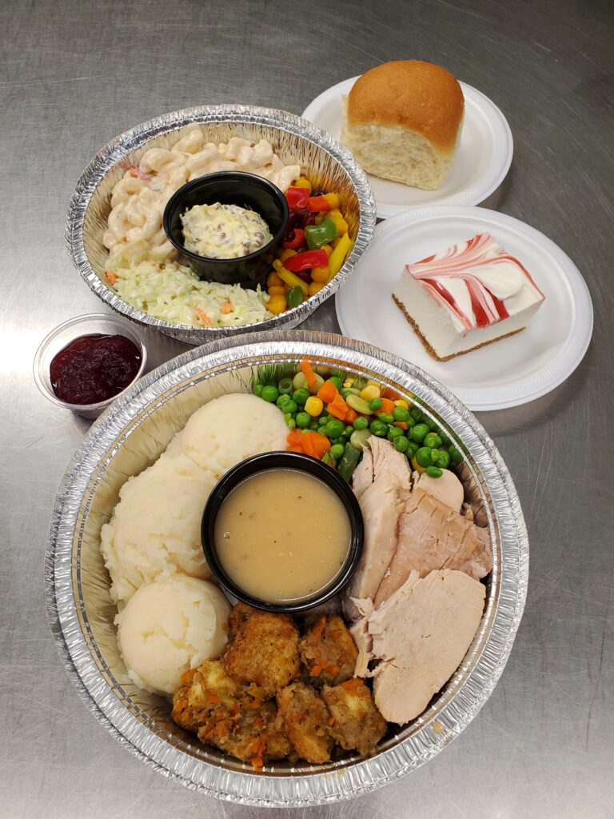
LIVING SKIES SPIRITUAL CARE
DRIVE-THRU DINNER FUNDRAISER
Saturday, April 10, 2021
5:00 – 6:00 p.m.
Enjoy a full turkey dinner for only $20! (No cooking, no dishes!)
- Prepared by Charlotte’s Catering
- Pre-order, pre-pay only
- Contactless drive-thru for your safety
- Pick-up at Westhill Park Baptist Church – 8025 Sherwood Drive
How to order:
E-transfer: Send an e-transfer to treasurer@livingskies.care. Be sure to indicate in the memo line the number of turkey dinners you are ordering.
Cheque: Mail a cheque to: Living Skies Spiritual Care 1304 Maple Leaf Crescent, Regina, SK S4X 4N5 Be sure to indicate in the memo line the number of turkey dinners you are ordering.
**If neither of these methods works for you, please contact treasurer@livingskies.care or call 306-580-9580 to discuss other options.
Living Skies Spiritual Care is a registered charity which supplies Multifaith Chaplain Services to the Regina General Hospital, Pasqua Hospital and Wascana Rehabilitation Centre.
www.livingskies.care OR Like us on Facebook
Chaplain Angela Fraser - 306-580-9580

