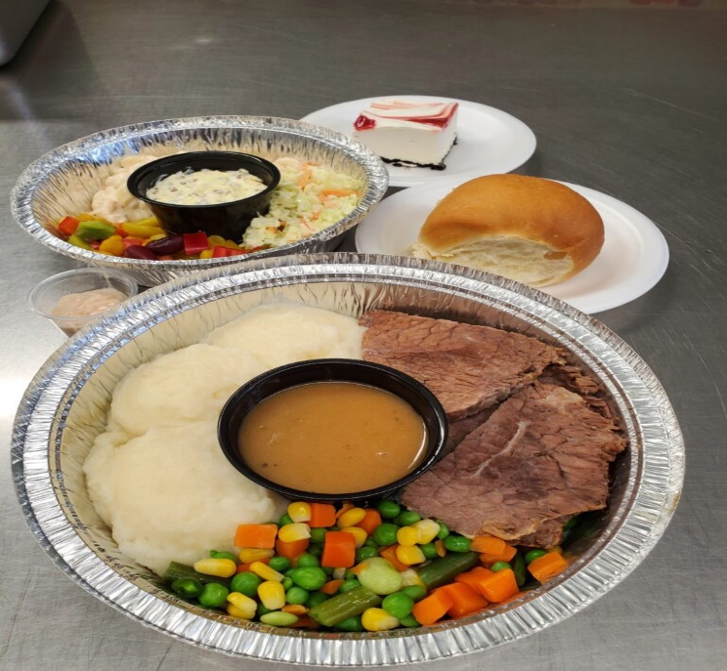
LIVING SKIES SPIRITUAL CARE
DRIVE-THRU DINNER FUNDRAISER
Friday, October 1, 2021
5:00 – 6:00 p.m.
Enjoy a full roast beef dinner for only $20! (No cooking, no dishes!)
- Prepared by Charlotte’s Catering
- Pre-order, pre-pay only
- Contactless drive-thru for your safety
- Pick-up at Westhill Park Baptist Church – 8025 Sherwood Drive
How to order (on or before Sept. 28):
E-transfer: Send an e-transfer to treasurer@livingskies.care. Be sure to indicate in the memo line the number of beef dinners you are ordering, as well as contact information so we can confirm your order with you. (No password needed – autodeposit).
Credit card – Pay by credit card on our website. Just go to www.livingskies.care, click on “Events”, then “Fundraisers” and follow the instructions.
**If neither of these methods works for you, please contact treasurer@livingskies.care or call 306-580-9580 to discuss other options.
Living Skies Spiritual Care Inc. is a registered charity which supplies Multifaith Chaplain Services to the Regina General Hospital, Pasqua Hospital and Wascana Rehabilitation Centre.
www.livingskies.care OR Like us on Facebook
Chaplain Angela Fraser - 306-580-9580

