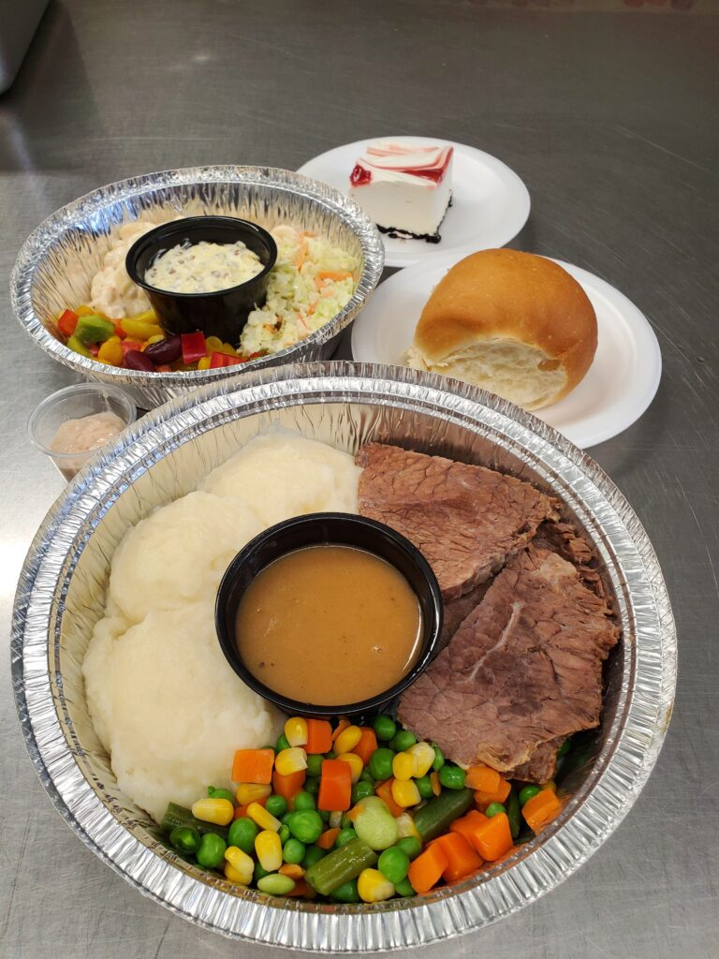
LIVING SKIES SPIRITUAL CARE
DRIVE-THRU ROAST BEEF DINNER FUNDRAISER
Saturday, October 15, 2022
5:00 – 6:00 p.m.
Enjoy a full roast beef dinner for only $25! (No cooking, no dishes!)
- Prepared by Charlotte’s Catering
- Pre-order, pre-pay only
- Contactless drive-thru for your safety
- Pick-up at Westhill Park Baptist Church – 8025 Sherwood Drive
How to order (on or before October 11):
E-transfer: Send an e-transfer to treasurer@livingskies.care. Be sure to indicate in the memo line the number of dinners you are ordering, as well as contact information so we can confirm your order with you.
Credit card – Pay by credit card on our website. Just go to www.livingskies.care, click on “Events”, then “Fundraisers” and follow the instructions.
**If neither of these methods works for you, please contact treasurer@livingskies.care or call 306-580-9580 to discuss other options.
Living Skies Spiritual Care Inc. is a registered charity which supplies Multifaith Chaplain Services to the Regina General Hospital, Pasqua Hospital and Wascana Rehabilitation Centre.
www.livingskies.care OR Like us on Facebook
Chaplain Angela Fraser - 306-580-9580

